Tag Knockin: https://getargeting-2026.vercel.app/tag-knockin-mice

- Remove top right image:
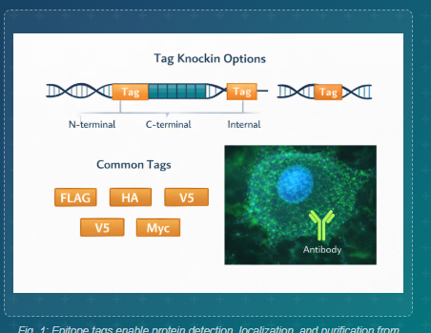

- Can you put a dash between “gene-specific”:
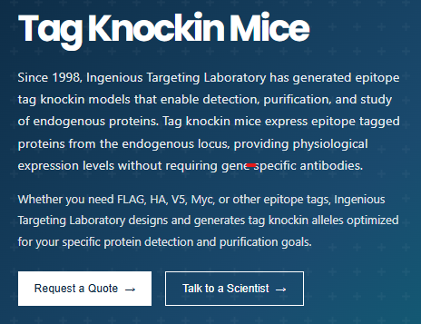

- Can you put a dash between “c-Myc”:

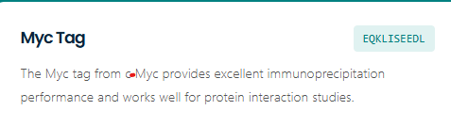
- Can you put a dash between “anti-tag”:
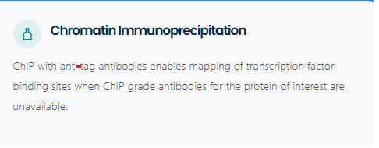

- And here too:
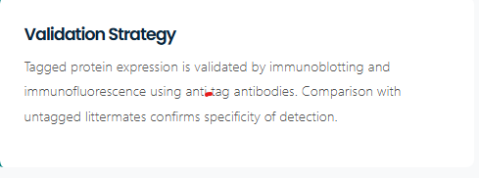

- The publications on this page are wrong. They should be (from FINAL doc):



